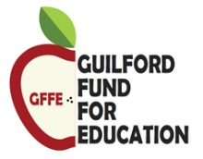

Thank you for contributing to the Guilford Fund for Education.

In order to continue to provide opportunities for excellence and innovation in education for students in Guilford, we need your support. We’re an all-volunteer organization, which means every single dollar donated to the GFFE Annual Campaign goes right back to benefit the kids in our community. Together, we are making a difference. All gifts, large or small expand the scope and reach of the GFFE.

Please complete the information below and mail it with your check to The Guilford Fund for Education, 800 Village Walk, #269, Guilford, CT 06437. The Guilford Fund for Education is a 501(c)(3), non-profit organization. Your donation is tax-deductible as allowed by law.

Amount: $__________________________________________________
First Name: _________________________________________________
Last Name: _________________________________________________
Street Address: _______________________________________________
City: ______________________________________________________
State: _____________________________________________________
Zip: _______________________________________________________
Email Address: _______________________________________________

